

# 

### Semester Two Examination, 2020

### Question/Answer booklet

# MATHEMATICS

**SOLUTIONS**

**APPLICATIONS**

**UNITS 3&4**

## Section Two:

## Calculator-assumed

|  |  |  |  |  |  |  |  |  |  |  |
| --- | --- | --- | --- | --- | --- | --- | --- | --- | --- | --- |
| WA student number: In figures |  |  |  |  |  |  |  |  |  |  |

In words

Your name

|  |  |
| --- | --- |
| Number of additional answer booklets used (if applicable): |  |

## Time allowed for this section

Reading time before commencing work: ten minutes

Working time: one hundred minutes

## Materials required/recommended for this section

***To be provided by the supervisor***

This Question/Answer booklet

Formula sheet (retained from Section One)

***To be provided by the candidate***

Standard items: pens (blue/black preferred), pencils (including coloured), sharpener,  
correction fluid/tape, eraser, ruler, highlighters

Special items: drawing instruments, templates, notes on two unfolded sheets of A4 paper, and up to three calculators approved for use in this examination

## Important note to candidates

No other items may be taken into the examination room. It is **your** responsibility to ensure that you do not have any unauthorised material. If you have any unauthorised material with you, hand it to the supervisor **before** reading any further.

## Structure of this paper

|  |  |  |  |  |  |
| --- | --- | --- | --- | --- | --- |
| Section | Number of questions available | Number of questions to be answered | Working time (minutes) | Marks available | Percentage of examination |
| Section One: Calculator-free | 8 | 8 | 50 | 52 | 35 |
| Section Two: Calculator-assumed | 13 | 13 | 100 | 98 | 65 |
|  | | |  | **Total** | 100 |

## Instructions to candidates

1. The rules for the conduct of examinations are detailed in the school handbook. Sitting this examination implies that you agree to abide by these rules.

2. Write your answers in this Question/Answer booklet preferably using a blue/black pen.  
Do not use erasable or gel pens.

3. You must be careful to confine your answers to the specific question asked and to follow any instructions that are specific to a particular question.

4. Show all your working clearly. Your working should be in sufficient detail to allow your answers to be checked readily and for marks to be awarded for reasoning. Incorrect answers given without supporting reasoning cannot be allocated any marks. For any question or part question worth more than two marks, valid working or justification is required to receive full marks. If you repeat any question, ensure that you cancel the answer you do not wish to have marked.

5. It is recommended that you do not use pencil, except in diagrams.

6. Supplementary pages for planning/continuing your answers to questions are provided at the end of this Question/Answer booklet. If you use these pages to continue an answer, indicate at the original answer where the answer is continued, i.e. give the page number.

7. The Formula sheet is not to be handed in with your Question/Answer booklet.

Section Two: Calculator-assumed 65% (98 Marks)

This section has**thirteen** questions. Answer **all** questions. Write your answers in the spaces provided.

Working time: 100 minutes.

Question 9 (5 marks)

The weights on the edges of the graph below are the flight times in hours between adjacent airports, represented by the vertices numbered to .

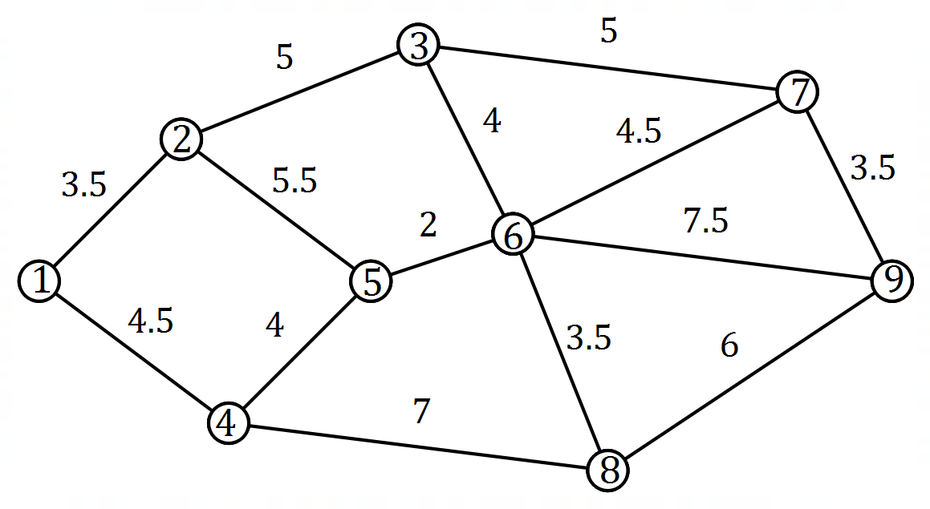

(a) Determine the minimum total flight time between airport and airport . (2 marks)

|  |
| --- |
| **Solution** |
| Airports : hours.  Airports : hours.  Airports : hours.  Minimum time is hours. |
| **Specific behaviours** |
| ✓ indicates times for several routes  ü minimum time |

(b) When planning a journey, a traveller allows minutes at each airport on their route, including the first and last, to allow for check in, transfers, baggage collection and so on. Determine the quickest route for this traveller from airport to airport and state their total journey time. (3 marks)

|  |
| --- |
| **Solution** |
| Airports : hours.  Airports : hours.  Quickest route: Airports .  Total journey time is hours. |
| **Specific behaviours** |
| ✓ indicates at least one correct journey time  ü correct route  ü correct journey time |

Question 10 (6 marks)

Using the declining balance method of depreciation, the value of an industrial machine at the end of its first year of use (year ) is and at the end of year is .

The value of the machine in dollars at the end of year can be modelled by the recurrence relation .

(a) Show mathematically how to derive the value in the recurrence relation from information in the question. (1 mark)

|  |
| --- |
| **Solution** |
|  |
| **Specific behaviours** |
| ✓ shows quotient |

(b) Write the rule for the term of this sequence. (1 mark)

|  |
| --- |
| **Solution** |
|  |
| **Specific behaviours** |
| ✓ correct formula |

(c) At the end of which year is the machine first valued at less than ? Justify your answer. (2 marks)

|  |
| --- |
| **Solution** |
| At the end of year .  but . |
| **Specific behaviours** |
| ✓ correct year  ü shows terms either side of |

(d) Determine the value of the machine when it was new (at the start of the first year) and hence calculate its total decline in value, to the nearest dollar, over its first five years of use. (2 marks)

|  |
| --- |
| **Solution** |
| Total decline in value is . |
| **Specific behaviours** |
| ✓ initial value  ü total decline |

Question 11 (6 marks)

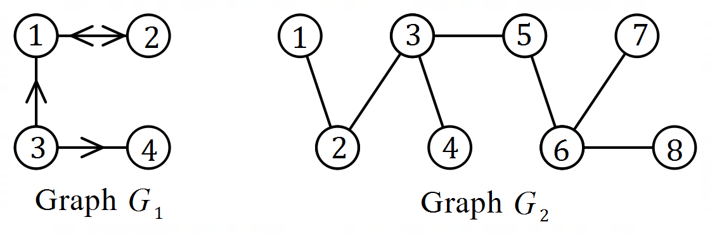(a) Connected graphs and  
 are shown at right.  
  
The adjacency matrices for  
 and are and   
respectively.

(i) Construct matrix . (2 marks)

|  |
| --- |
| **Solution** |
|  |
| **Specific behaviours** |
| ✓ square matrix  ü correct matrix |

(ii) Determine the number of entries in that are . (2 marks)

|  |
| --- |
| **Solution** |
| will have entries. There are edges in and each will lead to two 's in and so that will leave entries that are in . |
| **Specific behaviours** |
| ✓ indicates will have entries  ü correct number |

(b) The adjacency matrix for graph is .  
  
State, with justification, whether is a simple graph. (2 marks)

|  |
| --- |
| **Solution** |
| No - there are multiple edges between some vertices (between and ). |
| **Specific behaviours** |
| ✓ states no with justification  ü justification |

Question 12 (7 marks)

The temperature , in degrees Celsius, of an oven minutes after being turned on can be modelled by the recurrence relation .

(a) Use the recurrence relation to complete the following table to the nearest degree Celsius.

(2 marks)

|  |  |  |  |  |  |  |
| --- | --- | --- | --- | --- | --- | --- |
|  |  |  |  |  |  |  |
|  |  |  |  |  |  |  |

|  |
| --- |
| **Solution** |
| See table |
| **Specific behaviours** |
| ✓ at least three correct values; ü all correct |

(b) Plot the temperature of the oven at one minute intervals on the axes below. (2 marks)

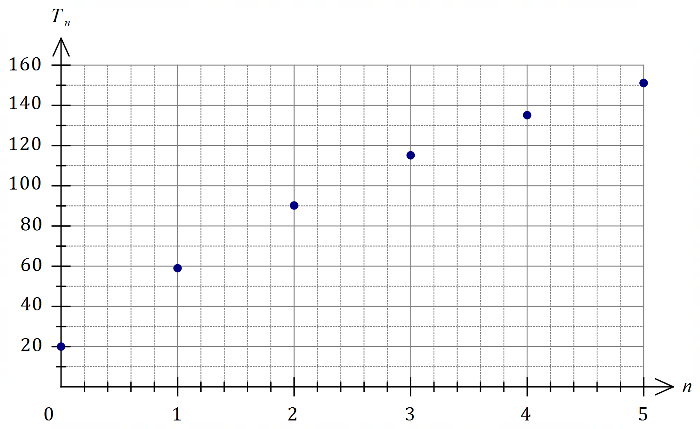

|  |
| --- |
| **Solution** |
| See graph |
| **Specific behaviours** |
| ✓ first and last points  ü all points correct |

(c) State the value of for which the temperature of the oven first exceeds . (1 mark)

|  |
| --- |
| **Solution** |
|  |
| **Specific behaviours** |
| ✓ correct value |

(d) Explain how the temperature of the oven changes in the long term. (2 marks)

|  |
| --- |
| **Solution** |
| The temperature increases become smaller and smaller as the temperature tends towards . |
| **Specific behaviours** |
| ✓ indicates tends to steady state  ü steady state temperature |

Question 13 (7 marks)

A person has a credit card account with an outstanding debt of and the card provider charges interest at a rate of per annum compounded daily.

(a) Determine their card debt in days' time if the card is not used for any more purchases and no repayments are made. (2 marks)

|  |
| --- |
| **Solution** |
|  |
| **Specific behaviours** |
| ✓ indicates method (possibly a financial calculator)  ü correct debt |

The person can pay off their card debt using an unsecured loan from their bank at an interest rate of compounded monthly.

(b) Use effective interest rates to determine, with reasoning, whether the unsecured loan would be a better option for this person. (3 marks)

|  |
| --- |
| **Solution** |
| Card:  Loan:  The loan is not a better option as the effective interest rate is higher. |
| **Specific behaviours** |
| ✓ one correct rate (to at least dp)  ü both correct rates  ü explains why loan is not a better option |

The person chose to pay off their card debt in full by taking out a two year secured loan for from a lender who compounds interest quarterly. At the end of this time, the person must repay the principal and interest, a sum of .

(c) Determine the interest rate charged by this lender. (2 marks)

|  |
| --- |
| **Solution** |
|  |
| **Specific behaviours** |
| ✓ indicates method (possibly a financial calculator)  ü correct rate |

Question 14 (10 marks)

A factory operates three consecutive eight-hour shifts A, B and C each day. The table below shows the number of workers who turned up late for each shift, together with a three-point moving average .

|  |  |  |  |  |
| --- | --- | --- | --- | --- |
| Time period | Day | Shift | Number late | Moving average |
|  | Sun | A |  |  |
|  | Sun | B |  |  |
|  | Sun | C |  |  |
|  | Mon | A |  |  |
|  | Mon | B |  |  |
|  | Mon | C |  |  |
|  | Tue | A |  |  |
|  | Tue | B |  |  |
|  | Tue | C |  |  |

(a) Briefly describe the purpose of calculating a set of moving averages for a time series.

(1 mark)

|  |
| --- |
| **Solution** |
| To smooth time series data and expose the underlying trend. |
| **Specific behaviours** |
| ✓ indicates smoothing |

(b) Determine the value of and the value of in the table above. (2 marks)

|  |
| --- |
| **Solution** |
|  |
| **Specific behaviours** |
| ✓ value of  ü value of |

(c) Determine the centred six-point moving average for . (2 marks)

|  |
| --- |
| **Solution** |
|  |
| **Specific behaviours** |
| ✓ indicates appropriate method to centre  ü correct average |

(d) Determine the least-squares line to predict from . (2 marks)

|  |
| --- |
| **Solution** |
|  |
| **Specific behaviours** |
| ✓ slope, to at least dp  ü intercept, to at least dp  *NB Using CAS, first entry for must be .* |

Two of the seasonal indices for the above time series are shown in the table below.

|  |  |  |  |
| --- | --- | --- | --- |
| Shift | A | B | C |
| Seasonal index |  |  |  |

(e) Calculate the seasonal index for shift C. (1 mark)

|  |
| --- |
| **Solution** |
|  |
| **Specific behaviours** |
| ✓ value of index |

(f) Forecast the number of late workers for the next B shift (on Wednesday), using the  
least-squares line from (d) and making any necessary seasonal adjustment. (2 marks)

|  |
| --- |
| **Solution** |
| Forecast late workers. |
| **Specific behaviours** |
| ✓ value using least-squares line  ü correct forecast, as whole number |

Question 15 (7 marks)

On March Dea started a new job with an annual salary of . At that time, the balance of her superannuation fund from previous jobs was . Dea's new employer deposits a sum equal to of her monthly salary into her fund on the last day of each month.

Interest on the balance of an individual's superannuation fund is added on the last day of each month, just before any deposits are made, and the fund advertises an interest rate of per annum.

(a) Determine the balance of Dea's superannuation fund on April . (3 marks)

|  |
| --- |
| **Solution** |
| Interest multiplier: .  Deposit: .  New balance: |
| **Specific behaviours** |
| ✓ interest multiplier (or interest amount)  ü deposit  ü correct balance |

(b) Write a recursive relation for the balance of Dea's superannuation fund months after she started her new job. (2 marks)

|  |
| --- |
| **Solution** |
|  |
| **Specific behaviours** |
| ✓ recursive part  ü initial term |

(c) Calculate the expected increase in the balance of Dea's superannuation fund after she has been in her new job for one year if her circumstances do not change. (2 marks)

|  |
| --- |
| **Solution** |
|  |
| **Specific behaviours** |
| ✓ correct balance after one year  ü correct increase |

Question 16 (8 marks)

The records of people who were hospitalised with an injury following a road accident have been categorised by road user group and main body region injured in the table below.

|  |  |  |  |  |
| --- | --- | --- | --- | --- |
|  | Shoulder | Head | Lower limb | Neck |
| Motorcyclist |  |  |  |  |
| Car occupant |  |  |  |  |

(a) Determine what percentage of those hospitalised were motorcyclists. (1 mark)

|  |
| --- |
| **Solution** |
|  |
| **Specific behaviours** |
| ✓ correct percentage |

(b) State the most common main body region injured by motorcyclists and what percentage of motorcyclists had this body region recorded as their main injury. (2 marks)

|  |
| --- |
| **Solution** |
| Shoulder, for of motorcyclists. |
| **Specific behaviours** |
| ✓ correct region  ü correct percentage |

(c) Complete the following table of row percentages, rounding to the nearest whole number.

(3 marks)

|  |  |  |  |  |
| --- | --- | --- | --- | --- |
| (%) | Shoulder | Head | Lower limb | Neck |
| Motorcyclist |  |  |  |  |
| Car occupant |  |  |  |  |

|  |
| --- |
| **Solution** |
| See table |
| **Specific behaviours** |
| ✓ at least two correct entries; ü one row correct; ü all entries correct |

(d) Do the records suggest the presence of an association between the categorical variables? Justify your answer. (2 marks)

|  |
| --- |
| **Solution** |
| Yes, because the percentages in each column (across categories) are quite different. For example, only of motorcyclists had neck as their main injury compared to of car occupants. |
| **Specific behaviours** |
| ✓ states yes to association  ü observes general differences or uses specific example |

Question 17 (11 marks)

The table below shows the percentage of all trips made using a bicycle and a car for nine countries. The correlation coefficient for the set of data is .

|  |  |  |  |  |  |  |  |  |  |
| --- | --- | --- | --- | --- | --- | --- | --- | --- | --- |
| Country |  |  |  |  |  |  |  |  |  |
| Bicycle trips, () |  |  |  |  |  |  |  |  |  |
| Car trips, () |  |  |  |  |  |  |  |  |  |

(a) Add the three missing points to the scatterplot below. (2 marks)

|  |
| --- |
| **Solution** |
| See scatterplot |
| **Specific behaviours** |
| ✓ correctly plots at least one point  ü correctly plots all three points |

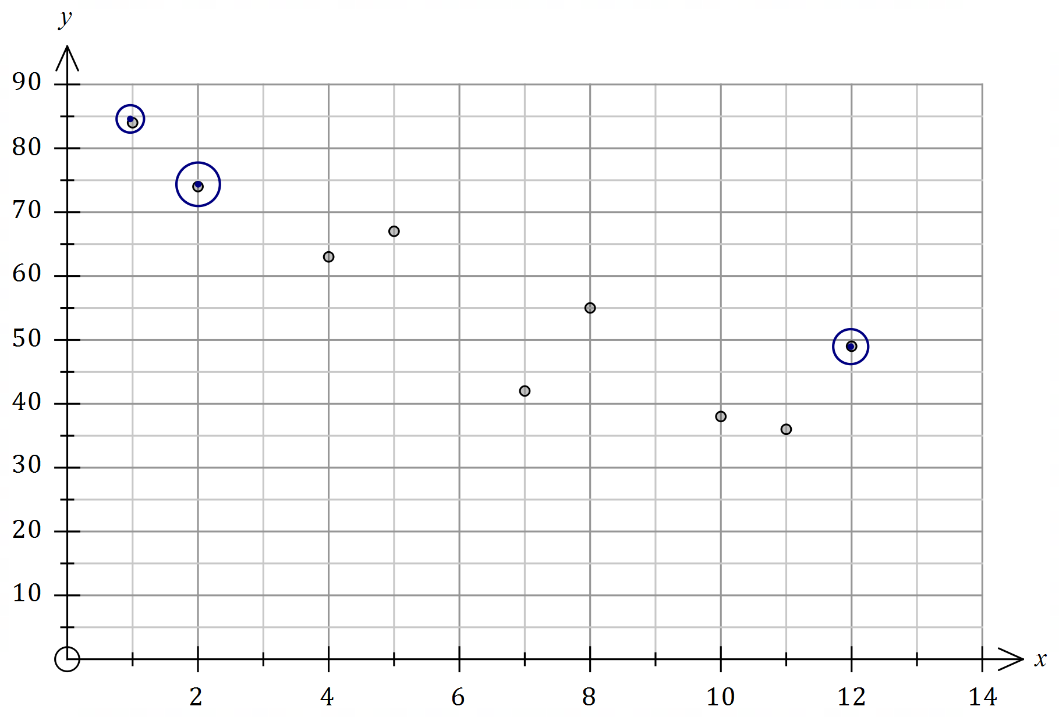

(b) A journalist discussed the dataset in an article with the headline "Decreasing bicycle use causes increase use of cars". Comment on their choice of headline. (2 marks)

|  |
| --- |
| **Solution** |
| The headline is misleading as the observed negative association between the variables does not necessarily mean that a change in car use is caused by a change in bicycle use. |
| **Specific behaviours** |
| ✓ indicates that headline is misleading/inappropriate/etc  ü comment(s) related to causation |

(c) Determine the equation of the least-squares line with as the explanatory variable.

(2 marks)

|  |
| --- |
| **Solution** |
|  |
| **Specific behaviours** |
| ✓ slope to at least dp  ü intercept to at least dp |

(d) In the context of the question, interpret

(i) the intercept of the least-squares line. (1 mark)

|  |
| --- |
| **Solution** |
| In a country where no trips were made by bicycle, close to of trips would be made using a car. |
| **Specific behaviours** |
| ✓ interpretation using intercept |

(ii) the slope of the least-squares line. (1 mark)

|  |
| --- |
| **Solution** |
| For every increase in the percentage of trips made by bicycle, there is an observed decrease close to in the percentage of trips made by car. |
| **Specific behaviours** |
| ✓ reasonable interpretation of negative gradient |

(e) In country , of all trips are made by bicycle. Predict the percentage of trips made using a car in this country and discuss factors related to the use of the fitted line that affect your confidence in this prediction. (3 marks)

|  |
| --- |
| **Solution** |
| The strong correlation coefficient of would usually lead to high confidence but due to the large amount of extrapolation, confidence in the prediction is low. |
| **Specific behaviours** |
| ✓ correct prediction (that rounds to given value)  ü discusses strong correlation  ü discusses extrapolation |

Question 18 (10 marks)

Data for the number of regional home sales per quarter, rounded to the nearest hundred homes, is shown in the table below.

|  |  |  |  |  |  |
| --- | --- | --- | --- | --- | --- |
|  | Year | Quarter | Sales (), in hundreds | Quarterly mean | Sales as percentage of quarterly mean |
|  |  |  |  |  |  |
|  |  |  |  |
|  |  |  |  |
|  |  |  |  |
|  |  |  |  |  |  |
|  |  |  |  |
|  |  |  |  |
|  |  |  |  |
|  |  |  |  |  |  |
|  |  |  |  |
|  |  |  |  |
|  |  |  |  |

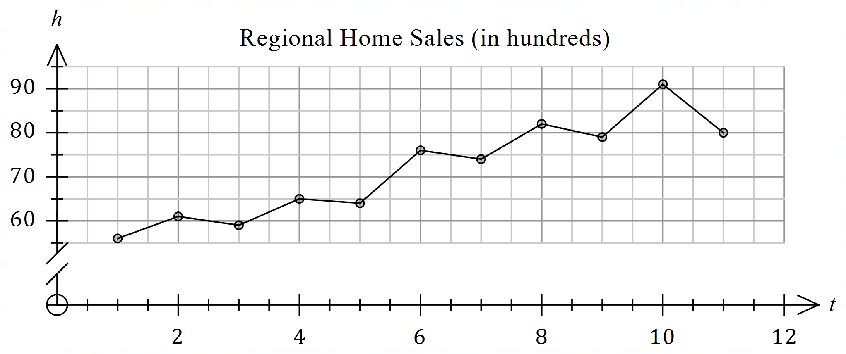

(a) Describe the trend and seasonality of this data. (2 marks)

|  |
| --- |
| **Solution** |
| There is an increasing trend.  In each year, sales tend to be lowest in Q1, increase in Q2, decrease in Q3 and end highest in Q4. |
| **Specific behaviours** |
| ✓ describes trend  ü describes seasonality |

(b) Calculate the value of , the value of and the value of in the table. (4 marks)

|  |
| --- |
| **Solution** |
| Let be quarterly mean for :  or |
| **Specific behaviours** |
| ✓ value of  ✓ value of  ✓ value of quarterly mean  ✓ value of |

(c) Determine the deseasonalised number of home sales in the region in the first quarter of . (3 marks)

|  |
| --- |
| **Solution** |
| The deseasonalised number of sales is homes. |
| **Specific behaviours** |
| ✓ calculates seasonal index  ü divides sales by index  ü value that rounds to and allows for hundreds |

3

(d) Forecast the actual number of home sales in the region for the first quarter of given that the least-squares trend line for the deseasonalised data indicates that the number of home sales to be at that time. (1 mark)

|  |
| --- |
| **Solution** |
|  |
| **Specific behaviours** |
| ✓ correct value that rounds to |

Question 19 (7 marks)

A company took out a business loan of at an interest rate of per annum and made monthly repayments of . The first few rows of a spreadsheet used by the company to track the loan balance is shown below.

|  |  |  |  |  |
| --- | --- | --- | --- | --- |
| Month, | Balance at start of month | Interest | Repayment | Balance carried forward |
|  |  |  |  |  |
|  |  |  |  |  |
|  |  |  |  |  |

(a) Determine the value of and the value of in the spreadsheet. (2 marks)

|  |
| --- |
| **Solution** |
|  |
| **Specific behaviours** |
| ✓ value of  ü value of |

A recurrence relation of the form can be used to model the balance of the loan at the start of month .

(b) Determine the value of each of the constants and in the recurrence relation.

|  |
| --- |
| **Solution** |
|  |
| **Specific behaviours** |
| ✓ value of (to at least dp)  ü value of and value of |

(2 marks)

(c) Using a financial calculator, or otherwise, state

(i) the balance of the loan after repayments. (1 mark)

|  |
| --- |
| **Solution** |
|  |
| **Specific behaviours** |
| ✓ correct value |

(ii) the number of repayments required to repay the loan. (1 mark)

|  |
| --- |
| **Solution** |
| months. |
| **Specific behaviours** |
| ✓ correct value |

(iii) the minimum monthly repayment for the full amount of the loan to be repaid at the same interest rate in equal repayments. (1 mark)

|  |
| --- |
| **Solution** |
|  |
| **Specific behaviours** |
| ✓ correct value |

Question 20 (7 marks)

Some consecutive terms of sequence are shown in the following table.

|  |  |  |  |  |  |
| --- | --- | --- | --- | --- | --- |
|  |  |  |  |  |  |
|  |  |  |  |  |  |

(a) State the name given to this type of sequence and determine , the first term of the sequence. (2 marks)

|  |
| --- |
| **Solution** |
| Arithmetic sequence. |
| **Specific behaviours** |
| ✓ name of sequence  ü first term |

(b) Determine a rule for the term of sequence in the form , where and are both constants. (2 marks)

|  |
| --- |
| **Solution** |
|  |
| **Specific behaviours** |
| ✓ uses rule on formula sheet  ü simplifies and states in required form |

The term of another sequence that has a constant difference is , so that   
and .

(c) Determine .(3 marks)

|  |
| --- |
| **Solution** |
|  |
| **Specific behaviours** |
| ✓ two values of sequence  ü common difference  ü correct term |

Question 21 (7 marks)

The balance of a savings account after monthly deposits have been made can be modelled by .

(a) Determine

(i) the amount deposited each month. (1 mark)

|  |
| --- |
| **Solution** |
|  |
| **Specific behaviours** |
| ✓ correct amount |

(ii) the annual interest rate of the savings account. (1 mark)

|  |
| --- |
| **Solution** |
|  |
| **Specific behaviours** |
| ✓ correct rate |

(iii) the balance of the savings account after monthly deposits have been made.

(1 mark)

|  |
| --- |
| **Solution** |
|  |
| **Specific behaviours** |
| ✓ correct amount |

After the monthly deposit, no further deposits are made.

(b) Calculate the total interest that the savings account received up to this time. (2 marks)

|  |
| --- |
| **Solution** |
|  |
| **Specific behaviours** |
| ✓ indicates appropriate method  ü correct amount |

The accumulated balance still attracts interest, compounded monthly at the same rate, and is used to fund an annual perpetuity.

(c) Determine the amount of the annual perpetuity. (2 marks)

|  |
| --- |
| **Solution** |
|  |
| **Specific behaviours** |
| ✓ indicates appropriate method  ü correct amount |

Supplementary page

Question number: _________

© 2020 WA Exam Papers. Kennedy Baptist College has a non-exclusive licence to copy and communicate this document for non-commercial, educational use within the school. No other copying, communication or use is permitted without the express written permission of WA Exam Papers. SN245-166-4.